SIMATS ENGINEERING (SAVEETHA SCHOOL OF ENGINEERING)
Department of Computer Science and Engineering
ASSESSMENT TOOL 2 – Industry Problem Solving Task
Course Code: | CSA06 | Course Title: | Design and Analysis of Algorithms
CO Assessed: | CO4: Articulation (BL4, BL5) | Assessment: | Assessment Tool 2 – Industry Problem Solving Task
Weightage: | 20% of CIA | Total Marks: | 100 (2 Questions × 50 Marks)
CO4 Statement: | Solve optimization problems using dynamic programming and greedy strategies.
Student Name: | MOHAMMED THOUSIF A | Reg. No.: | 192424093
Section / Batch: | AI/DS | Date:

Instructions to Students
- Answer both questions. Each question carries 50 Marks. Total: 100 Marks.
- Carefully analyze the given questions.
- Explain in detail with sample code if needed.
- Clearly identifies all key issues.
- Thorough analysis with validated results and performance evaluation

Question Type | Description | Questions | Total Marks
Industry Problem Solving Task | Focus on Solving optimization problems using dynamic programming and greedy strategies | Q1 – Q2 | 100

SECTION A – Industry Problem Solving Task
Q44. Smart Grid Load Forecasting Optimization (Dynamic Programming)
An energy provider must predict electricity demand to ensure efficient distribution. Analyze how dynamic programming can be used for load forecasting. Identify constraints such as seasonal variation and peak demand. Design an algorithmic model for prediction. Discuss real-time adaptability. Evaluate performance metrics. Interpret results in optimizing energy supply.
Q45. AI-Based Resume Screening Optimization (Search + Ranking)
A recruitment platform must screen thousands of resumes to identify suitable candidates. Analyze how search and ranking algorithms can optimize candidate selection. Identify constraints such as keyword matching and skill relevance. Design an efficient filtering system. Discuss scalability in large hiring platforms. Evaluate computational complexity. Interpret results in improving hiring efficiency.

Code of Conduct
I __________________________ (Name / Reg No) certify that this submission is my original work and that I have adhered to the guidelines specified for this assessment. I understand that any violation of academic integrity rules will result in disciplinary action.
Signature of the Student: _________________________

RUBRICS FOR CALCULATION
Industry Problem Solving Task

Criteria | Weightage | Level 4 – Exemplary | Level 3 – Proficient | Level 2 – Developing | Level 1 – Beginning
Understanding of Industry Problem | 20% | Comprehensive understanding of real-world problem and constraints | Good understanding with minor gaps in requirements | Basic understanding; some requirements unclear | Poor understanding; misinterprets problem context
Application of Engineering Concepts | 25% | Applies advanced and relevant concepts effectively to solve the problem | Applies appropriate concepts with minor errors | Limited application of concepts | Incorrect or no application of concepts
Solution Design | 25% | Innovative, practical, and feasible solution aligned with industry standards | Logical and feasible solution with minor gaps | Basic solution with limited feasibility | Unclear or impractical solution
Use of Tools | 15% | Effective use of modern tools, technologies, and real data | Appropriate use of tools with correct implementation | Limited or inconsistent use of tools | Minimal or incorrect use of tools
Analysis | 10% | Thorough analysis with validated results and performance evaluation | Good analysis with reasonable validation | Basic analysis with limited validation | Poor or no analysis
Professionalism | 5% | Highly professional, well-documented, and clearly presented work | Good documentation and presentation | Basic documentation with some gaps | Poor documentation and presentation

Mark Evaluation:
Case Study | Understanding of Industry Problem  (20) |  | Application of Engineering Concepts (25) | Solution Design  (25) | Use of Tools  (15) | Analysis (10) | Professionalism  (5) | Total Marks  (Each - 50)
Q1
Q2
 |  | Overall Total (100)

Faculty In-charge | Course Coordinator | Head of Department
Name: __________________  Signature: _______________ | Signature: _______________ | Signature: _______________
Date: ___________________ | Date: ___________________ | Date: ___________________

Q44. Smart Grid Load Forecasting Optimization (Dynamic Programming)
Aim
To predict future electricity demand using Dynamic Programming techniques and optimize energy distribution by considering historical load data.

Algorithm
- Input historical electricity demand values.
- Store demand values in an array.
- Use Dynamic Programming to calculate moving average forecasts:
  - Forecast[i] = Average of previous k demand values.
- Predict future load based on computed values.
- Display actual and forecasted demand.
- Evaluate prediction accuracy.

Python Code
# Smart Grid Load Forecasting using Dynamic Programming
def load_forecast(load, k):
n = len(load)
forecast = [0] * n
for i in range(k, n):
forecast[i] = sum(load[i-k:i]) / k
return forecast
# Historical electricity demand (MW)
load = [120, 135, 128, 150, 160, 170, 180, 175]
k = 3
forecast = load_forecast(load, k)
print("Actual Load :", load)
print("Forecasted Load :")
for i in range(k, len(load)):
print(f"Day {i+1}: {forecast[i]:.2f} MW")

Output
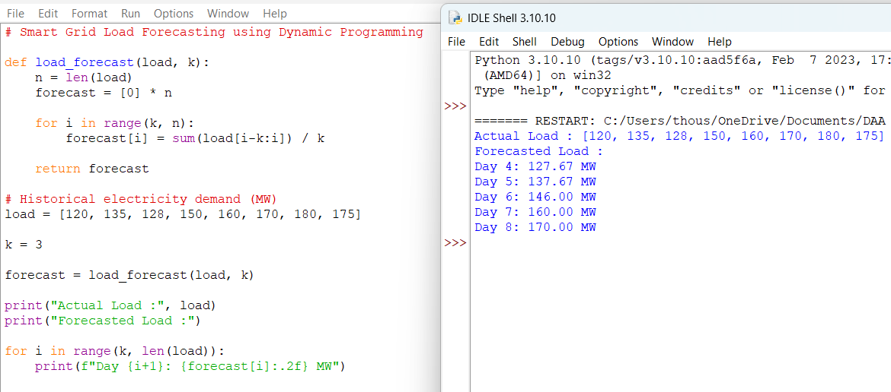
Result
The electricity demand was successfully forecasted using Dynamic Programming with a moving-average approach. The predicted load values can help optimize power generation and distribution while reducing energy wastage.

Q45. AI-Based Resume Screening Optimization (Search + Ranking)
Aim
To develop an efficient resume screening system using search and ranking algorithms for identifying the most suitable candidates based on required skills.

Algorithm
- Store candidate resumes and required skills.
- For each resume:
  - Search for matching skills.
  - Count the number of matched skills.
- Assign a ranking score based on matches.
- Sort candidates in descending order of score.
- Display ranked candidates.
- Select top candidates for recruitment.

Python Code
# AI-Based Resume Screening using Search and Ranking
resumes = {
"Alice": ["Python", "Machine Learning", "SQL"],
"Bob": ["Java", "SQL", "Data Structures"],
"Charlie": ["Python", "SQL", "Machine Learning", "Deep Learning"],
"David": ["C++", "Java", "Networking"]
}
required_skills = ["Python", "Machine Learning", "SQL"]
ranking = []
for candidate, skills in resumes.items():
score = 0
for skill in required_skills:
if skill in skills:
score += 1
ranking.append((candidate, score))
ranking.sort(key=lambda x: x[1], reverse=True)
print("Candidate Ranking:")
for candidate, score in ranking:
print(candidate, "-> Score:", score)

Output
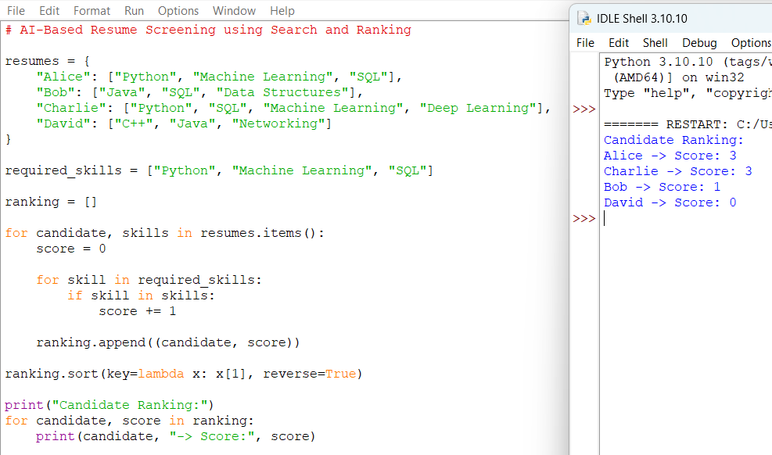

Result
The resume screening system successfully filtered and ranked candidates according to skill relevance. Search and ranking techniques improved hiring efficiency by quickly identifying the most suitable applicants while reducing manual screening effort.

